AGENDA - Little Hoole Parish Council
Members of the Council are summoned to the Parish Council Meeting to be held on
Mon 8th January 2024 at 7pm,
The Lounge, Old Mill Court, Liverpool Old Road, Walmer Bridge, PR4 5QU
Paul Cafferkey, Clerk & Responsible Financial Officer

- Apologies for absence
- To agree the Minutes of the last Parish Council Meeting
- To receive declarations of interest
- Matters arising from the minutes of last meeting
  - Public Time: to invite and listen to issues raised by members of the public
  - Panning Applications:
    - 07/2023/01020/NMA, Fair Acre Farm Moss Lane, Little Hoole, PR4 4SX. Non-Material Amendment to planning approval 07/2023/00331/FUL for the proposed re-siting of Plots 3 and 4
    - 07/2023/01012/FUL, Unit 2 Longton Business Park Station Road Little Hoole, PR4 5LE. Change of use from general industrial (class b2)/storage/distribution (class b8) to gymnastics centre (class e) together with alterations to the front elevation (south eastern facing) to create a new glazed entrance and a new roller shutter opening. new fire doors are proposed in the south eastern and south western elevations.
  - To approve the following transactions in the bank for Dec 2023.
Current a/c Dec 2023
Date | Payee | £ | Description
1-Dec-23 | Direct Debit (GOCARDLESS) | 33.60 | Monthly website subscription
6-Dec-23 | B/P to: Paul Cafferkey | 80.47 | Clerk's Salary Tax Mth 8
7-Dec-23 | B/P to: Hoole Scout Group | 534.00 | Grant to Hoole Scout Group
18-Dec-23 | B/P to: HMRC Cumbernauld | 27.20 | Clerk’s Tax to HRMC re Tax Mth 7
18-Dec-23 | B/P to: Paul Cafferkey | 62.49 | Clerk's Expenses Tax Month 9
18-Dec-23 | B/P to: HMRC Cumbernauld | 30.00 | Clerk’s Tax to HRMC re Tax Mth 9
18-Dec-23 | B/P to: HMRC Cumbernauld | 11.00 | Clerk’s Tax to HRMC re Tax Mth 8
18-Dec-23 | B/P to: Paul Cafferkey | 155.20 | Clerk's Salary Tax Month 9
22-Dec-23 | B/P to: Autocross Euroshel | 15,577.20 | 2 x Bus Shelters, supplied & installed by Autocross Euroshel Ltd
31-Dec23 | Service Charge | 18.00 | Bank charges for quarter
Instant Access a/c Dec 2023
31-Dec-23 | Credit Interest | -132.00 | Interest on Instant Access a/c

  - Payments for approval - Clerk’s claim for Dec 2023
  - Payments approved by email or pre-approved and retrospectively noted - None
  - To approve financial statement as at 31st Dec 2023
  - To approve the precept for 2024-25
  - To approve the setting up of a direct debit to HMRC for the payment of employee’s tax.
  - To review bank standing orders & direct debits
  - To review and approve the parish council’s asset register
  - To approve a letter to South Ribble Borough Council requesting a litter/dog waste bin adjacent to the bridge in Dob Lane recreation ground
  - VAT Return – Update
  - Summer Planting
  - Defibrillators – Update
  - SPiD (Speed Indicator Device) sign relocation – update
  - Calendar of key decisions and responsibilities
  - Correspondence, None
  - To agree the date and time for the Feb 2024 meeting
Members of the public are welcome to attend meetings to raise any relevant matters. Alternatively, if you cannot attend the meeting but wish to raise a matter or ask a question, this can be done on your behalf by contacting the Parish Clerk (Paul Cafferkey) via email at or mobile phone 07966267186.

Scan me to go the Little Hoole Parish Council Website, or visit https://www.littlehooleparishcouncil.org.uk/
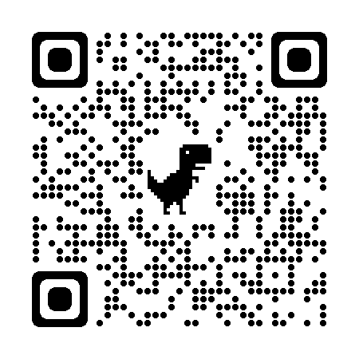
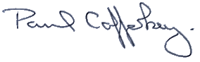
Prepared and approved by Paul Cafferkey, Clerk – Little Hoole Parish Council,

